

EXPERIMENT - 4

# Aim:

To install Kubectl and execute Kubectl commands to manage the Kubernetes cluster and deploy Your First Kubernetes Application.

# Theory:

After successfully creating the Kubernetes cluster, you can now deploy your application to it using the kubectl.

You need to create manifest’s for your project.

* Deployment.yaml : You actual app deploying
* service.yaml : To access your app outside the network in public.

Before moving forward you can install kubectl in your system using package manager:

□ ~ □ sudo pacman -S kubectl

Some common terms in manifest:

In Kubernetes manifests, you’ll encounter several common terms and concepts. Here’s a brief overview of some key ones:

* + kind: Should be Deployment.

apiVersion: Specifies the API version, e.g., apps/v1.

•

metadata: Contains the name, namespace, labels, and annotations of the deployment.

* + spec: The specification for the deployment.
  + replicas: Number of pod replicas to run.
  + selector: Defines how to select pods managed by the deployment.
  + • matchLabels: Key-value pairs for selecting pods.

template: The pod template that describes the pods.

* + - metadata: Labels for the pods.
    - spec: Defines the containers and their configurations.
      * containers: List of container specs.
        + name: Name of the container.
        + image: Container image to use.

ports: List of ports to expose.

•

env: Environment variables for the container.

* + - * + volumeMounts: Specifies where to mount volumes in the container.

Service manifest:

* + apiVersion: Typically v1.

kind: Should be Service.

•

metadata: Contains the name, namespace, labels, and annotations of the service.

* + spec: The specification for the service.
  + selector: Defines which pods the service will target based on labels.
  + ports: List of ports exposed by the service.
    - port: Port that the service will expose.
    - targetPort: Port on the container to forward traffic to.
  + type: Defines the service type (e.g., ClusterIP, NodePort, LoadBalancer).

Here’s mine:

deployment.yaml



apiVersion: apps/v1 kind: Deployment metadata:

name: node-deployment

namespace: thrifty labels:

app: node-api spec:

replicas: 2 selector:

matchLabels: app: node-api

template:

metadata:

labels:

app: node-api spec:

containers:

- name: node-api

image: darkkernel/node-api ports:

- containerPort: 8080

Service.yaml



apiVersion: v1 kind: Service metadata:

name: external-svc

namespace: thrifty labels:

app: external-svc spec:

type: LoadBalancer ports:

- port: 80

targetPort: 8080 protocol: TCP

selector:

app: node-api

1. Now let’s start with deployment, check if the cluster is ready.

□ ~ □ kubectl get nodes NAME

ip-192-168-26-47.ec2.internal ip-192-168-33-0.ec2.internal

## STATUS

Ready Ready

## ROLES

<none>

<none>

AGE

5m32s 5m43s

VERSION v1.30.2-eks-

1552ad0 v1.30.2-eks- 1552ad0

1. Get your project in your system.
   * git clone https://github.com/Dark-Kernel/node-api.git Cloning into 'node-api'//.

remote: Enumerating objects: 1513, done. remote: Counting objects: 100% (337/337), done.

remote: Compressing objects: 100% (194/194), done.

remote: Total 1513 (delta 126), reused 337 (delta 126), pack-reused 1176 (from 1) Receiving objects: 100% (1513/1513), 2.16 MiB | 5.71 MiB/s, done.

Resolving deltas: 100% (357/357), done.

>

* + cd node-api/
  + ls Kubernetes/

□ deployment.yaml □ service.yaml

1. Create Namespace if required
   * kubectl create namespace thrifty namespace/thrifty created
2. Now, create the deployment using the kubectl command.
   * kubectl apply -f Kubernetes/deployment.yaml deployment.apps/node-deployment created
3. You can check if it is applied.
   * kubectl get deployments -n thrifty

## NAME

node-deployment

## READY

2/2

UP-TO-DATE 2

AVAILABLE 2

AG E

27s

1. Then deploy the service
   * kubectl apply -f Kubernetes/external-svc.yaml service/external-svc created
2. Now, you can check your service if it is done.
   * kubectl get svc -n thrifty

## NAME PORT(S)

external-svc

## TYPE AGE

LoadBalancer

## CLUSTER-IP 10.100.232.57

EXTERNAL-IP

ab920d95efa3948538adb0e2601628be-396837232.us-

east-1.elb.amazonaws.com

80:31713/TCP 107s

Now using the external IP, which is a subdomain actually you can access your application. And our application deployment is successful

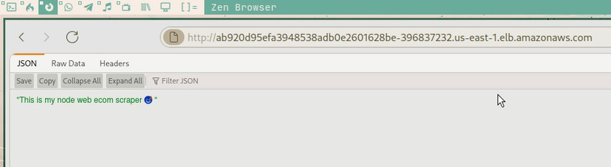

Conclusion: Thus, we have successfully installed Kubectl and execute Kubectl commands to manage the Kubernetes cluster and deployed our First Kubernetes Application.